corTEC Level Sensors in Industrial Use

Leinfelden-Echterdingen, 7 January 2020. The incorruptible corTEC level sensors now also prove themselves in rough industrial environments. New developments of the sensor platform allow for the contract-free detection of particularly viscous media. These include greases and solvents, oils, varnishes, hot wax, bulk goods or even food and beverages.

corTEC level sensors ensure the incorruptible and faultless detection of liquid columns and conditions in a tank. The capacitive sensors perform continuous and contact-free measurements through the non-conductive tank wall. They precisely distinguish between liquid films, drops, condensate or dust and cannot be deceived by moisture, vibrations, heat, cold or ageing processes. The evaluation algorithms compensate external disturbances.

For the sensor it doesn’t matter how viscous, adhesive or conductive a medium is. Up till now contact-free level sensors have reached their limits in such applications requiring reliable measurements of strongly adhesive media. If physical effects are located in a frequency range outside the range of the system incorrect measurements can easily occur.

Commissioned by renowned OEM-partners EBE adapts the corTEC platform for extreme applications. So far appliances have been the most important applications. “This development is a bold step forward. However, we have proven that the capacitive measuring principles are also suitable for demanding and rough ambient conditions. Thus, we can install the sensors in applications that have a high demand for error-resistent level measurement in industrial environments. The sensor platform has already proven itself in a couple of projects”, explains Armin Wellhöfer, managing director of EBE. The level sensor is particularly useful for machine building, plant engineering and car manufacturing, for chemical, cleaning, filling and medical engineering or for the agricultural and food industry. The technology is particularly suitable when it comes to measurements involving the formation of deposits and residues of liquids on the inner walls of tanks and rod probes

The corTEC platform excites the measuring electrodes in a defined spectrum range before it evaluates by means of a multi-channel capacitive measuring process. If necessary, this can be combined with tank presence recognition in removable tank systems.

The evaluation algorithms which can be designed for a great variety of ambient and usage conditions are part of EBE’s exclusive know how. The technology can also be used for mere detection tasks. Thus, hose surveillance applications can also be realized.

“Just like capaTEC, the corTEC platform is particularly suitable for removable tank systems and applications with several tank walls to be penetrated”, Armin Wellhöfer points out. The level sensors are located outside the tank in the tank recess, behind a protective wall or in an indestructible tight housing where they cannot be touched or damaged. For OEM-partners EBE designs and manufactures level solutions ready for mounting, if desired incl. housing and customized interface.
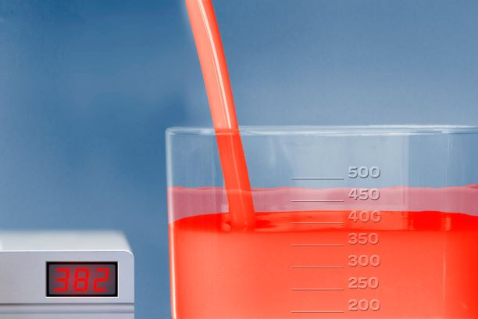
Picture file: Fuellstand_corTEC_EBE.jpg

Picture text: New developments of the corTEC level sensors from EBE are suitable for rough industrial applications. The corTEC principle is based on a capacitive measuring
process. The sensor system distinguishes liquid columns, film, drops, condensate, dust, etc.

Picture source: EBE Elektro-Bau-Elemente GmbH

Publication of photos is licence-free and free of charge. Source information requested.

Short Profile
The company EBE Elektro-Bau-Elemente GmbH (brand name EBE sensors + motion) based in Leinfelden-Echterdingen offers OEM-solutions in the fields of sensor and actuating technology, mechatronics, drive technology and magnetic engineering. EBE develops customized solutions and manufactures serial products for OEM customers. The focus lies on capacitive and inductive sensors, among others for level monitoring based on sensor technologies developed in-house as well as mechatronic systems. A further focus lies on intelligent door opening modules for appliances or sensor systems for white goods, medical engineering and mobility. The sensor program also includes level sensors, pressure sensors, position sensors and capacitive switches. Furthermore, EBE manufactures solenoids for a variety of applications as well as robust rotary switches, buttons and encoders and adapts them to the customer requirements. The company sees itself as a competence center for the development and production of sensor systems and drive technology.

Contact
EBE Elektro-Bau-Elemente GmbH
Managing Director, Armin Wellhöfer
Sielminger Str. 63, 70771 Leinfelden-Echterdingen, Germany
Tel. +49 711 79986-0, E-Mail: press@ebe.de

