Capacitive Buttons Cope With Dirt
Accumulation and Cooling Lubricants

Leinfelden-Echterdingen, 18 February 2020. Capacitive buttons and slide controls can work even under the most adverse conditions.
EBE sensors + motion from Leinfelden-Echterdingen demonstrate this in current industrial projects. The company develops special algorithms and electrode structures for machine and plant engineering. In this way, capacitive switches in robust design do their jobs even in dirty environments. They work reliably even under the influence of cooling lubricants, oils and coatings.

The electrodes developed by EBE are specially designed for the applied multi-channel measuring process. Individual evaluation algorithms and electrode structures are part of the company’s exclusive know-how. They can be designed for a variety of different operating conditions and sensitivity levels. Even the operation with soiled work gloves can be learned.

The buttons and slide controls of the capacitive sensor systems are maintenance free. Their service life amounts to several hundred million switching cycles. EBE designs housings matching the design and application of the customer or individually adapts them to existing housings. To give an example, they can be designed as sterile versions or as resistant to vandalism for the highest protection classes (IP67 to IP69K). Beyond that, the capacitive switches can be combined with displays and touch panels.

„Capacitive sensor systems from EBE work completely independent of external conditions. They increasingly serve as platforms for capacitive buttons and slide controls“, reports Armin Wellhöfer, managing director of EBE, about current projects. For instance, a manufacturer of food processing machines installs such buttons. Neither condensing steam nor accumulated dirt affect the reliable operation of the buttons. Even operating the capacitive switches with gloves works safely.

“It all depends on the evaluation algorithms and the electrode structure of the capacitive sensor”, EBE points out. The engineers of the company parameterize the algorithms individually for each application. In doing so, they consider the environmental influences, assembly situation, shape, material and thickness of housing, type of glasss, coatings and further factors.

The algorithms distinguish accidental gestures from a targeted touch. In this way, they prevent unintentional switching. They compensate parasitic capacitances. Conductive bodies near the button generate such disturbances. Likewise, influences by water, film, fog, dust, dirt, temperature and electromagnetic fields can be compensated.

The switches are suitable for applications in machine, plant and automotive engineering or in the construction, agricultural and food industry. Our company sees further markets in building, traffic, medical, chemical and filling technology. For OEM-partners EBE designs and manufactures solutions ready for mounting. Apart from the button or sliding switch they include the electronics including firmware and customer-specific housings, a front panel, a display or special interfaces.

Photo
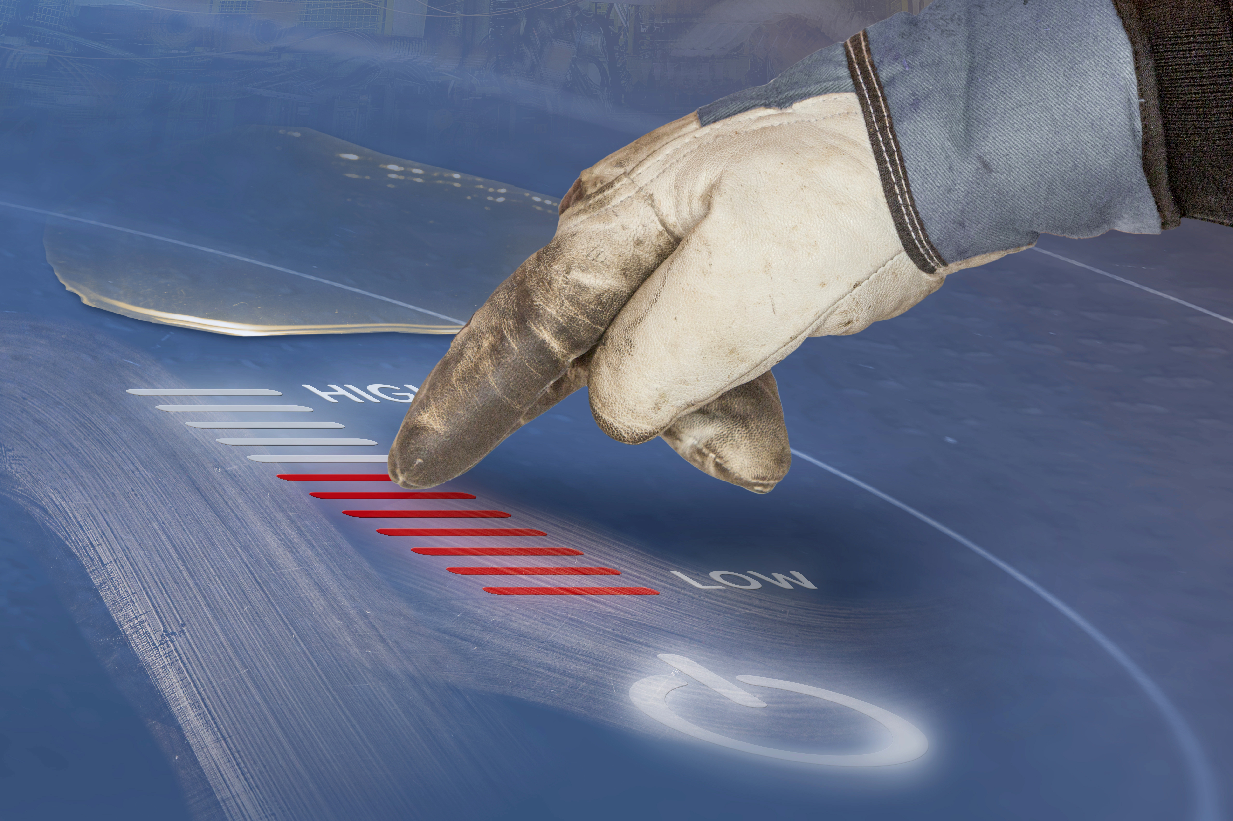
Picture file: kapazitive_Tasten_Slider_EBE.jpg

Picture text: The sensor systems of the capacitive buttons and slide controls from EBE function in a multi-channel way and can mask out dirt and other coatings as well as other disturbing sources of error. The algorithms distinguish accidental gestures from a targeted touch. Picture source: EBE Elektro-Bau-Elemente GmbH

Publication of photos is licence-free and free of charge. Source information requested.

Short Company Profile
The company EBE Elektro-Bau-Elemente GmbH (brand name EBE sensors + motion) based in Leinfelden-Echterdingen offers OEM-solutions in the fields of sensor and actuating technology, mechatronics, drive technology and magnetic engineering. EBE develops customized solutions and manufactures serial products for OEM customers. The focus lies on capacitive and inductive sensors, among others for level monitoring based on sensor technologies developed in-house as well as mechatronic systems. A further focus lies on intelligent door opening modules for appliances or sensor systems for white goods, medical engineering and mobility. The sensor program also includes level sensors, pressure sensors, position sensors and capacitive switches. Furthermore, EBE manufactures solenoids for a variety of applications as well as robust rotary switches, buttons and encoders and adapts them to the customer requirements. The company sees itself as a competence center for the development and production of sensor systems and drive technology.

Contact
EBE Elektro-Bau-Elemente GmbH
Managing Director, Armin Wellhöfer
Sielminger Str. 63, 70771 Leinfelden-Echterdingen, Germany
Tel. +49 711 79986-0, E-Mail: press@ebe.de

