From Dishwasher to Robot - New Tasks for Powerful Actuators from EBE

Leinfelden-Echterdingen, 17 March 2020. Enormous force in smallest installation space, full thrust within milliseconds, high-resolution travel-angle-recognition in any position; these are the properties intelligent actuators from EBE sensors + motion possess. So far, the mechatronic musclemen have been locking and unlocking appliances. Now they are advancing into the industrial sector. EBE develops new modules for machine engineering and robotics.

EBE wants to increasingly introduce its actuator know-how into markets with even more extreme requirements. Apart from machine engineering, automation and robotics these include the construction industry, cleaning industry medical and lab technology, commercial vehicles, public transportation sector, agricultural and food industry. Armin Wellhöfer: “We see a high demand for powerful, quick, small and maintenance-free modules for automated locking and unlocking and for push operation.”

“The actuator concept of our door opening modules can be applied to tasks in rough industrial environments. We are currently demonstrating this in projects for machine engineering and robotics.” This is what Armin Wellhöfer reports about new developments made by the mechatronics manufacturer based in Leinfelden-Echterdingen. The actuator concept has already proved itself in the restaurant trade and kitchens, especially in dishwashers. Automated locking systems and door openers for these devices must be intuitive to use, fail-safe, long-lived, robust and error resistant.

The opening modules reach a linear force of up to several 10 kg. If brushless motors are used the force reaches the plunger within milliseconds. This allows for high positioning speeds. At the same time these motors are almost noiseless so that they can be applied in areas where high noise development is not allowed. If cost optimisation is an issue EBE recommends powerful brush motors. Solenoids can also take over the power work.

The travel-angle-sensor system is based on inductive technology. They are placed on the PCB of the module and achieve high angle resolutions at very attractive costs. Our company finds a few cubic centimetres space to house the complete package: motor, gear, plunger, PCB and sensor system. The engineers design the firmware, algorithms, housing and mounting solution for each individual application. As an OEM-partner EBE manufactures solutions ready for assembling, on demand including power supply unit and connection to proprietary bus systems. If necessary, the modules can be fed via field bus (power-over-bus).

Photo
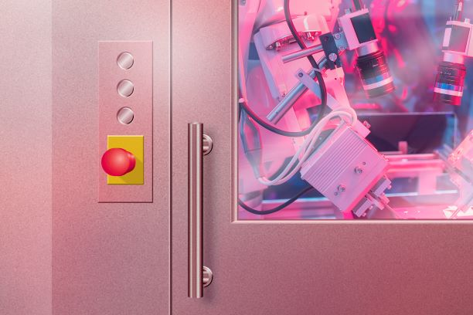
Picture file: Mech_Module_EBE.jpg

Picture text: Opening modules from EBE develop high forces in small installation space to lock and unlock doors in rough environments. The actuator system can be extended, among other things, by a high-resolution travel-angle-sensor system for robotics applications. Picture source: EBE Elektro-Bau-Elemente GmbH

Publication of photos is licence-free and free of charge. Source information requested.

Short Company Profile
The company EBE Elektro-Bau-Elemente GmbH (brand name EBE sensors + motion) based in Leinfelden-Echterdingen offers OEM-solutions in the fields of sensor and actuating technology, mechatronics, drive technology and magnetic engineering. EBE develops customized solutions and manufactures serial products for OEM customers. The focus lies on capacitive and inductive sensors, among others for level monitoring based on sensor technologies developed in-house as well as mechatronic systems. A further focus lies on intelligent door opening modules for appliances or sensor systems for white goods, medical engineering and mobility. The sensor program also includes level sensors, pressure sensors, position sensors and capacitive switches. Furthermore, EBE manufactures solenoids for a variety of applications as well as robust rotary switches, buttons and encoders and adapts them to the customer requirements. The company sees itself as a competence center for the development and production of sensor systems and drive technology.

Contact
EBE Elektro-Bau-Elemente GmbH
Managing Director, Armin Wellhöfer
Sielminger Str. 63, 70771 Leinfelden-Echterdingen, Germany
Tel. +49 711 79986-0, E-Mail: press@ebe.de

